The purpose of this document is to share with the Customer a summary of the integrated system requirements so that they can plan and coordinate resources in preparation for a functional evaluation of the PKS platform.

# Hardware Requirements

|  |  |  |  |  |  |  |
| --- | --- | --- | --- | --- | --- | --- |
| Cluster | No. of Hosts | CPU Cores Per Host | Memory Per Host | NICs Per Host | Shared Datastore | |
| PKS Cluster (Minimum) | 3 | 24 | 96 | 1x 10GbE | | 2.5 TB |

Note: Increasing the number of hosts will ease the per host resource requirements and expand the resource pool for deploying additional or larger Kubernetes clusters, applications, other integrations, etc.

# Software Requirements

Note: For the most current information, visit the [VMware Product Interoperability Matrices](https://www.vmware.com/resources/compatibility/sim/interop_matrix.php#interop&356=&2=&1=&175=&116=&88=) and [PKS Release Notes](https://docs.pivotal.io/runtimes/pks/1-4/release-notes.html)

|  |  |  |  |
| --- | --- | --- | --- |
| Product | Supported Version | Required / Optional | Download Location |
| VMware ESXI Hypervisor | 6.5 U1 | U2, 6.7 U1 | U2 | Required | [VMware Product Downloads](https://my.vmware.com/web/vmware/downloads) |
| VMware vCenter | 6.5 U2, 6.7 U1 | U2 | Required |
| Pivotal Cloud Foundry Operations Manager | 2.6.0 Build 138 | Required | [Pivotal Network](https://network.pivotal.io/) |
| Pivotal Container Service (PKS) | 1.4.0 Build 31 | Required |
| VMware Harbor Container Registry for PCF/PKS | 1.7.5 | Optional |
| Stemcell(s) for PCF/PKS/Harbor | 250.63 vSphere | Required |

# Network Requirements - Physical Network Configuration – Layer 2/3

Note: Provision the following networks in the physical infrastructure and extend access to all participating ESXi hosts.

|  |  |  |  |  |  |
| --- | --- | --- | --- | --- | --- |
| VLAN | Phy. Interface | Virtual Switch | MTU | Min. CIDR | Routable |
| Main Network* | NIC 1 | vDS or vSS | $≥$ 1500 | $≥$/24 | Yes |

* If the ESXi hosts’ management vmkNIC exists on a separate network, routing is required between the two networks.

One Single Routable VLAN Network is the minimum enough to setup PKS Infrastructure, PKS Main and PKS Services subnets that will be used during the installation. But you can setup 3 separate VLANs as long as you allow traffic amongst them.

Ops Manager and Bosh must have HTTPS access to vCenter and ESX hosts on TCP port 443

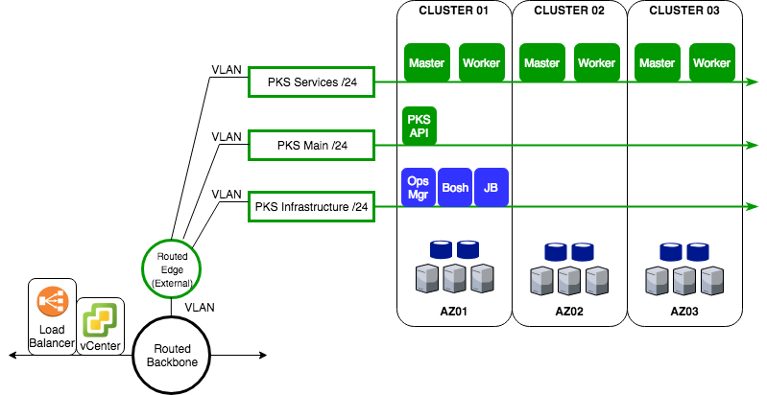

# Enterprise Service Requirements

**DNS –**Many PKS systemcomponents require Unique Resource Records and access to domain name servers for forward and reverse resolution.

**NTP** - Many PKS system management components require access to a stable, common network time source; time skew < 10 seconds

**Firewall –** Unfiltered traffic between the networks above is HIGHLY RECOMMENDED for the evaluation. Firewall requirements are available.

**AD/LDAP** (Optional) – Service bind account, User/Group DNs, Server(s) FQDN, and port required for authentication with external identity providers

**Administrator and Test Terminals –**The VMware/Pivotal PKS Systems Engineer will require access to a connected Linux machine for platform installation, configuration, and test verification.